Search Term Analysis

**Current Reality**

We have limited visibility of what content users are searching for and are unable to find.

|  |  |
| --- | --- |
| **Problem Statement** | **Opportunity** |
| Search terms doesn’t bring search results 1. We do not have content for in our database.  2. We know the search term with some other name (synonyms, chemical formula). | Our content upgrade efforts can be more focused on what our prospects and customers are seeking |
| Search terms for which we only have Static Content | We can make informed decisions to add interactive content for frequently searched terms that enhance user experience |
| Missing Property 1. We do not have content for in our database.  2. We know the search term with some other name (synonyms). | A missing property, even if one, could be significant as it may apply to multiple substances. |

1. In case of no result in graph search, the searched term should be tracked. Also, it should be captured that ML result is available or not.
2. In case of no result in graph search due to no matching synonym/chemical formula, the searched term should be tracked. Also, it should be captured that ML result is available or not.
3. In case of only static content available in graph result, the searched term should be tracked.

**Impact:**

**Current Customer Experience:** To gain insights about missing search terms and inform the business to think of content upgrades that help advance discovery.

**Sales:** We can improve the conversion ratio by enhancing the experience of trialling users.

**Marketing:** Allows Marketing colleagues to have focused discussion around content that matters the most to the prospect.

**Product Enhancement:** Focus our long term product enhancement efforts on what users are currently looking for.

**Penetrating new segments:** We capitalize on an upcoming business opportunity if we are aware of such search terms early on.

\*\***Note**: (We can also consider following category of search terms in our problem statement)

1. Separate section for looking for most ***trending terms/data in materials science***. Business can purchase that data if that is currently not in our existing Database. **Impact**: Building confidence for our product among potential customers and help onboard many new customers.
2. Enhance ***students experience*** by looking for ***terms most often searched*** as per **academic curriculum**. Reaching out University Librarians or university official website can help getting academic curriculum for every year. **Impact:** Help in reaching out students another target customers. It would build better teaching solutions for students.

For phase 2:

1. Potentially, maybe we want to categorise a search term based on the frequency. For now we will only capture the number and importance of a search term will be defined manually.
2. Author name
3. Structure search - structures that didn’t result in any outcome.
4. Element system - element systems that didn’t result in any outcome

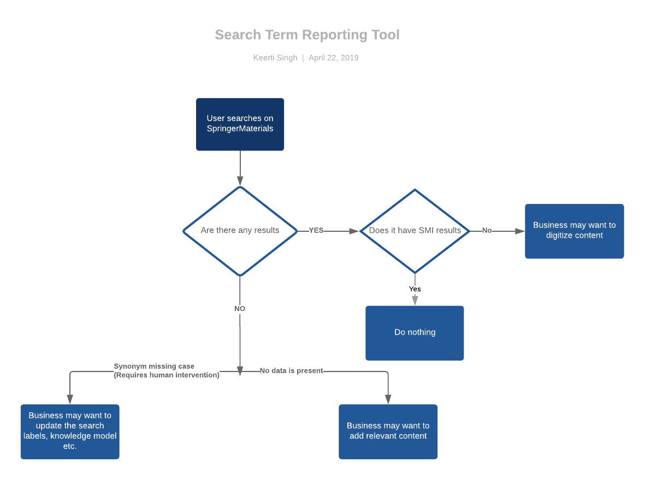

Front end details:

1. There should be a link which anyone can open to see the report.
2. The format of the report should be tabular.
3. Following should be the columns for the table: Search Term, Page Views, Contextual, Non Contextual, No. of Graph Results, No. of Marklogic Results
4. Nice to have: filter to select a particular date range.

Later thoughts:

1. Static content is available or not can be reported which can help in making digitization decisions.
2. Another dashboard can be created which can have verified stats by SME/BA, which can be used by business for decision making.